**What are the TestNG Listeners you used in your project?**

**What are Listeners?**

Listeners are TestNG annotations that literally “listen” to the events in a script and modify TestNG behavior accordingly. These listeners are applied as interfaces in the code. There are various listeners like IAnnotationTransformer, ITesttListener , IReporter.

For example, in my project I have used IAnnotation Transformer and IRetryAnalyzer to retry the failed testcases by adding listener tag in my testing.xml file.

Listener used in my project:

- I have employed Listeners to handle situations where test cases fail due to random browser issues, browser unresponsiveness or unexpected server delays causing issues with the server response. In such cases, we can implement test case rerun using the IAnnotationTransformer Listener.

- To implement this, I first created a RetryEngine which is a user-defined class, which implements the IRetryAnalyzer interface. This interface contains the retry method where we define the logic for retrying failed test cases.

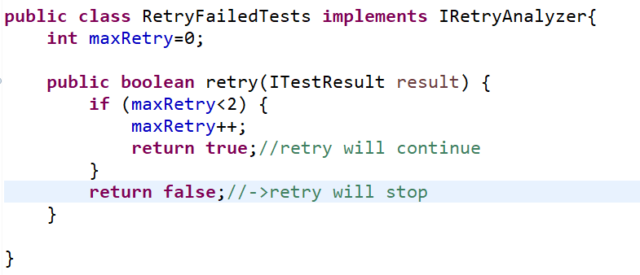

Subsequently, I utilized the IAnnotationTransformer interface, which includes the transform method.This method is used to apply the retry logic to all test cases.

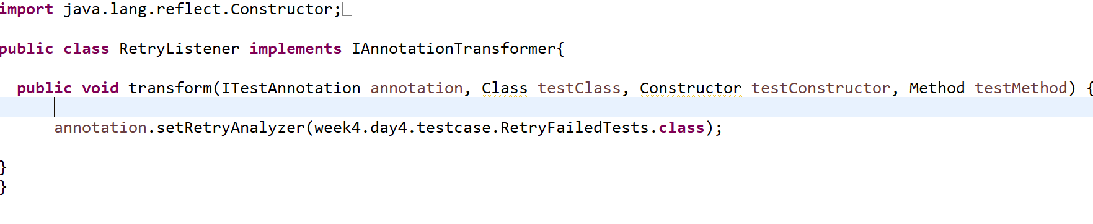

Finally, I configured the listeners in the XML file using the <Listeners> tag.

